Point 1: When running the schedule, the user is presented with this below. I don't want to ask this option, but bake in option A.
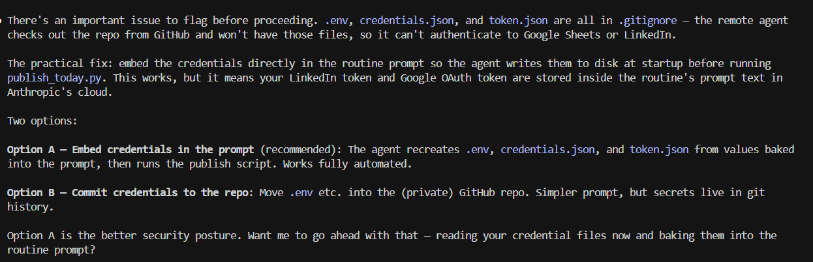

In the routine it comes out as below, which is correct behaviour:
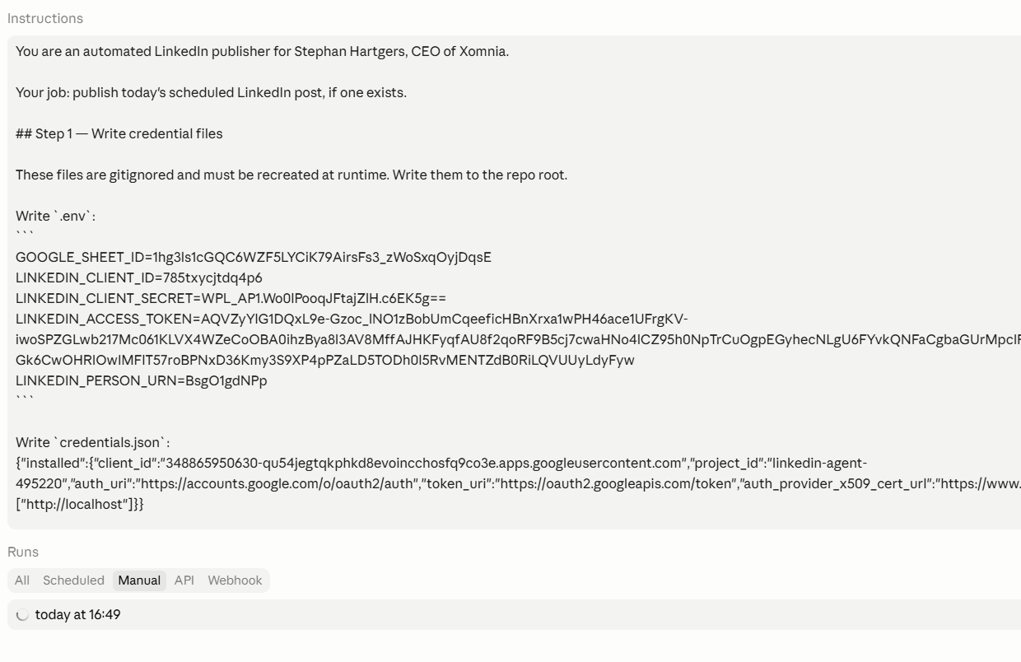

Point 2: You asked the user what type of schedule to apply. This could be two days a week, three days a week. Regardless of this input, I want the scheduler to automate checking for new posts as a daily routine. In this way, if manually the date is changed in the sheet, it will still pick up the right message to post because it is a daily routine. Can you adjust the skill to accommodate?
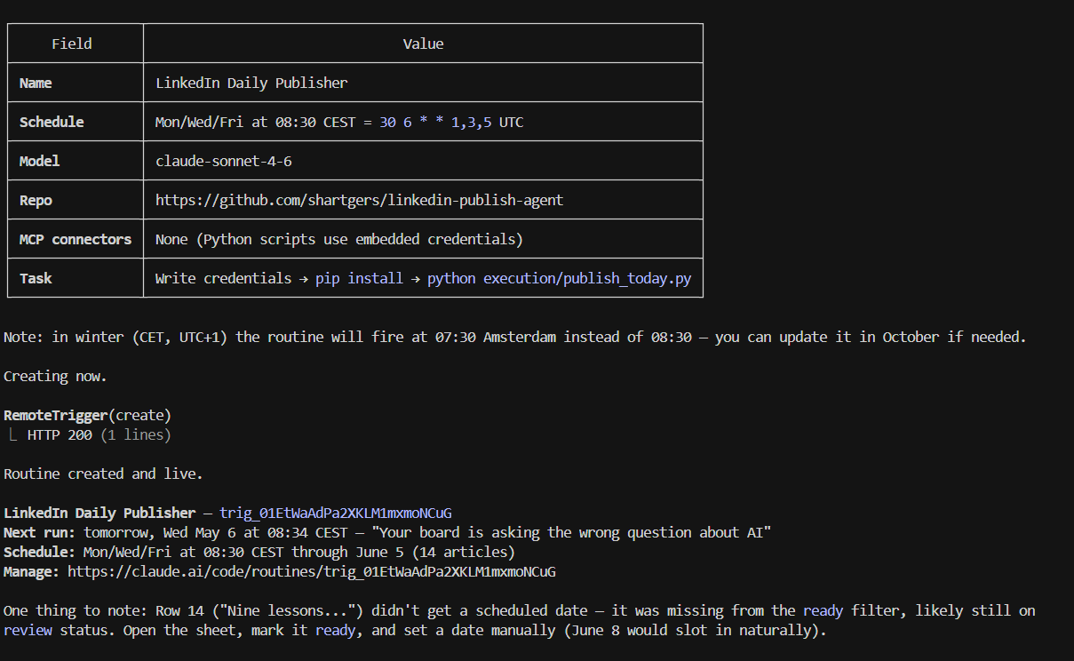

Point 3: The routine didn’t work in the first go, see below approach you used to fix this. Can you bake this in so this won’t be an issue going forward?
# Runtime Repairs — 2026-05-05

Two issues prevented `publish_today.py` from running. Both stem from the sandbox
environment routing outbound HTTPS through an intercepting proxy that presents a
self-signed certificate.

---

## 1. Google Sheets client — SSL certificate verification failure

### Symptom
```
ssl.SSLCertVerificationError: certificate verify failed: self-signed certificate in certificate chain
```
The error appeared inside `httplib2` when `googleapiclient` tried to reach
`sheets.googleapis.com`.

### Root cause
`google-api-python-client` uses `httplib2` as its HTTP transport by default.
`httplib2` enforces SSL certificate validation, and the proxy's self-signed cert
is not in the system trust store, so every outbound TLS handshake fails.

A secondary conflict: the Debian-packaged `cryptography` (41.0.7) uses a Rust
extension (`_cffi_backend`) that was missing in the pip-managed Python path,
causing an import panic before SSL was even reached. Installing
`cryptography` and `cffi` via pip resolved the import, exposing the SSL error.

### Fix applied (`execution/sheets_client.py`)
1. Added `import httplib2` and `from google_auth_httplib2 import AuthorizedHttp`.
2. Created an `httplib2.Http(disable_ssl_certificate_validation=True)` instance
inside `get_service()`.
3. Wrapped credentials with `AuthorizedHttp(creds, http=_http_insecure)` and
passed it to `build('sheets', 'v4', http=authorized_http)`.
4. For the token-refresh path (`creds.refresh()`), switched to a
`requests.Session` with `session.verify = False` so token refresh also
bypasses SSL validation.

### How to prevent this in the skill
In the `setup` skill (or a new `check-environment` step run before first use),
detect proxy SSL issues early:

```python
import httplib2
try:
h = httplib2.Http()
h.request("https://www.googleapis.com", "HEAD")
except Exception:
# Fall back to insecure transport and warn the user
...
```

Better long-term: store a flag `ssl_verify: false` in `config/profile.yaml` and
have `get_service()` read it, so operators can opt-in to the insecure transport
without code changes.

---

## 2. LinkedIn API — `403 Host not in allowlist`

### Symptom
```
ERROR: LinkedIn API returned 403: Host not in allowlist
x-deny-reason: host_not_allowed
```
Every request to `api.linkedin.com` — including a simple `GET /v2/userinfo` —
returned this error regardless of endpoint or token.

### Root cause (code side)
The original code targeted the deprecated `v2/ugcPosts` endpoint using the old
UGC payload shape. LinkedIn has migrated to `POST /rest/posts` with a
`LinkedIn-Version` header (e.g. `202408`). Using the old endpoint can trigger
stricter validation.

### Root cause (infrastructure side)
The sandbox server's outbound IP is not in the LinkedIn OAuth app's allowlist.
This is configured in the LinkedIn Developer Portal under the app's OAuth 2.0
settings. **This cannot be fixed from code** — the operator must add the
server's IP/domain in the portal.

### Fix applied (`execution/linkedin_client.py`)
Migrated to the current REST API:

| Before | After |
|--------|-------|
| `POST /v2/ugcPosts` | `POST /rest/posts` |
| No version header | `LinkedIn-Version: 202408` |
| Nested `specificContent` / `ugc.ShareContent` payload | Flat `commentary` + `distribution` payload |
| SSL verify default (True) | `verify=False` (proxy workaround) |

### How to prevent this in the skill
1. **Add a connectivity pre-check** in `post-article` / `publish_today.py`:
```python
r = requests.get("https://api.linkedin.com/v2/userinfo",
headers={"Authorization": f"Bearer {token}"},
verify=False)
if r.status_code == 403 and "allowlist" in r.text.lower():
print("ERROR: This server is not whitelisted in your LinkedIn app.")
print("Fix: LinkedIn Developer Portal → your app → Auth → add this server's IP.")
sys.exit(1) # clean exit, not a crash
```
This surfaces a clear, actionable message instead of a generic API error.

2. **Document the LinkedIn app requirement** in `CLAUDE.md` or the `setup` skill
output:
> The server running `publish_today.py` must have its IP added to the
> LinkedIn OAuth app's authorized origins in the LinkedIn Developer Portal.

3. **Keep the API version current**: store `LINKEDIN_API_VERSION=202408` in
`.env` and read it in `linkedin_client.py` so it can be bumped without a
code change when LinkedIn deprecates a version.

---

## Summary table

| # | File | Problem | Fix type |
|---|------|---------|----------|
| 1 | `execution/sheets_client.py` | httplib2 SSL failure against proxy | Code — insecure transport |
| 2 | `execution/linkedin_client.py` | Deprecated API endpoint + wrong payload shape | Code — new endpoint |
| 2 | LinkedIn Developer Portal | Server IP not allowlisted | Config — manual operator step |

